Caterpillar to Butterfly

The caterpillar slithers in its nest.

The caterpillar slithers on the ground.

The caterpillar likes to eat leaves C:\Users\krueger-west\AppData\Local\Microsoft\Windows\Temporary Internet Files\Content.IE5\CU8VVQMR\MC900310684[1].wmf **CRUNCH CRUNCH**

It eats leaves C:\Users\krueger-west\AppData\Local\Microsoft\Windows\Temporary Internet Files\Content.IE5\CU8VVQMR\MC900310684[1].wmf **CRUNCH CRUNCH**

It **LOVES **leaves! C:\Users\krueger-west\AppData\Local\Microsoft\Windows\Temporary Internet Files\Content.IE5\CU8VVQMR\MC900310684[1].wmf**CRUNCH CRUNCH**

Then one day

The caterpillar builds a  **CHRYSALIS**

And then we wait**TICK TOCK TICK TOCK**

Day after day after day after day we wait **TICK TOCK TICK TOCK**

Until it becomes a butterfly** YEAH**

One spring day we take the butterfly out side

And we open up the net and say C:\Users\krueger-west\AppData\Local\Microsoft\Windows\Temporary Internet Files\Content.IE5\Y65017HH\MC900078717[1].wmf **good-bye**

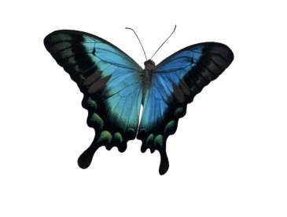**Butterfly**

**C:\Users\krueger-west\AppData\Local\Microsoft\Windows\Temporary Internet Files\Content.IE5\Y65017HH\MC900078717[1].wmfGood-bye**

**BUTTERFLY**